Enhancing authentication security via Graphical and QR code verification

Divya Maheshwari
Department of CSE
ABES Engineering College
Ghaziabad, India
maheshwari.divya84@gmail.com
Harsh Krishnatre
Department of Computer Science
ABES Engineering College
Ghaziabad,India
hkrishnatre@gmail.com
Harshvardhan
Department of Computer Science
ABES Engineering College
Ghaziabad,India
harshvardhanmaurya73073@gmail.com
Sandip
Department of Computer Science
ABES Engineering College
Ghaziabad,India
smavisoftwares@gmail.com

Abstract— This project is about setting up a secure multi-factor authentication framework for web platforms that combines security questions, image-based pattern authentication, and changing single-use secret codes. The registration procedure recognized different user identities by checking existing records and also ensured the safe storage of encrypted secret codes and verification patterns. The login method integrates QR code based interactions with a dedicated authentication application that challenges users with puzzles and changing color-number combinations, thus significantly increasing resistance to unauthorized access. To regain credentials, the system deploys time-limited tokens sent through emails, which allow users to securely reset their authentication methods and security questions. This in-depth approach thoroughly keeps the security strong.
This approach securely guards confidential data and at the same time facilitates smooth access control by making security features intuitive to the users.
Keywords— React.js, Microservices, Node.js, Deployment Automation (Kubernetes)

INTRODUCTION
In the realm of digital technology, the use of practical, efficient and safe authentication mechanisms for protecting users' private data and allowing authorized access to platforms has become a matter of utmost importance. This project serves the purpose of introducing a more efficient and secure user authentication method with the integration of traditional security questions, image pattern recognition, and dynamic one-time secret codes which serves the purpose of effective and secure user authentication.
The verification of existing user accounts, and the secure retention of hashed data, secrets along with codes, and patterns enable the system’s registration to ensure proper singular user identification. During the login process, a QR code which is customized for the user’s data is produced and enables the use of a specialized puzzle and pattern authenticator app which is interactive. This authentication mechanism enhanced security by relying on authentication patterns which cannot easily be replicated or stolen.
The email-sent temporary tokens flow in the pattern and password reset process and the mechanism allows users to securely change their passwords without compromising the system. The incorporation of multiple alterations of authentication, system ease of use, and effective system response to unauthorized access and replay attacks has increased the system’s protection a great amount.
This solution ensures secure user authentication through interactive and multi-modal verification techniques, thus allowing a smooth user experience while at the same time being scalable and adaptable to a variety of application domains where secure user authentication is a must.

Motivation and Impacts of Security Failures

- The Rising Costs of Security Failures (2014-2024)

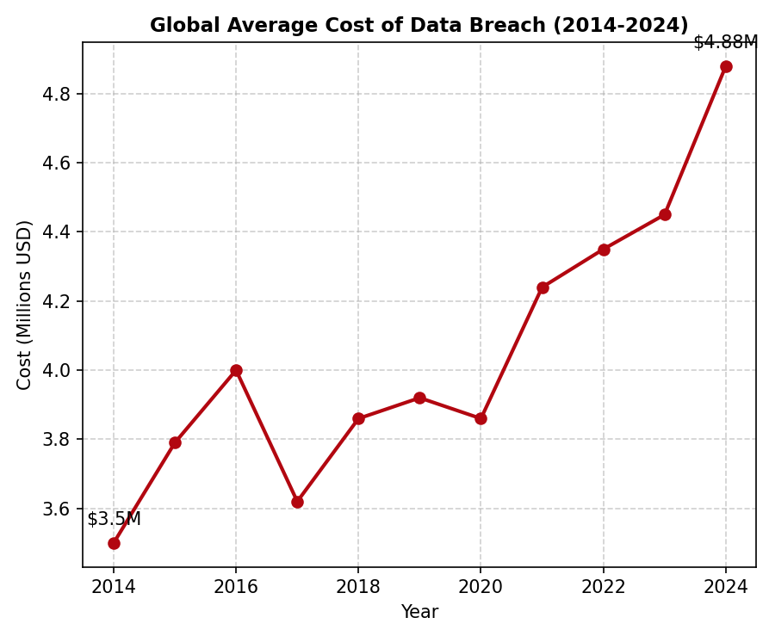
Figure 1. Global Average Cost of Data Breaches
Operationally, financially, and from a reputation standpoint, the impacts of data breaches can be extremely harmful. There is a concerning upwards trend when analyzing data breaches over the last 10 years, as illustrated in Figure 1. The global average costs of data breaches increased from 3.5 million in 2014 to 4.88 million in 2023, which is an almost 40% increase in the last 10 years.
Consequences in the form of money lost such as breach response, forensic investigations, legal expenses, and regulatory penalties are direct financial losses. In the USA, the total average cost of an incident is over 8 million dollars. In the occurrence of an attack, companies are obliged to immediately suspend or limit service, which brings monetary losses, in payments for online services. In companies that are affected, there are long-term indirect financial expenses like over expensive security renovations, increased insurance payments, and continuing monitoring. For instance, Verizon promised to spend over 300 million dollars on security upgrades following the breaches on Yahoo which is 5 times the amount of money Yahoo was previously spending.

- The "Mega Breach" Anomaly

Company | Year of Impact | Financial Cost
Adobe | 2013 | ~$2 million+
Yahoo | 2013-2016 | $502.5 million
Uber | 2016-2018 | $148.1 million
Equifax | 2017 | $589 Million+
Facebook | 2018-2019 | $5 Billion
Table 1.Financial Impact of "Mega Breaches"
In spite of how these systemic failures of authentication result in "Mega Breaches" and their associated costs, most of the world\'s average costs are very low. Table 1 shows that, in particular, cases of lost credentials result in costs that are multifactor of the average.
- Facebook (2018): A failure to protect user data after the Cambridge Analytica scandal cost the company a $5 billion fine from the FTC and $134 billion of market value in a week.
- Equifax (2017): Not patching and properly securing admin accounts allowed a breach that would end up costing over $575 million in settlements and fines and a 13% decrease in stock value.
- Yahoo (2013–2016): 3 billion account compromises cost the company $350 million from the reduced purchase price from Verizon and over $150 million in fines and settlements.

- Effects on User Trust and Retention
Breach also impacts trust and reputation that’s not easily quantified in monetary terms. Investor concerns and negative media attention can be sparked by high-profile events. Clients and partners expect data to be secure and 65% of victims say their trust has been violated when a breach occurs. Studies show that as many as 80% of customers will defect from a business when their personal data is exposed.
Consequently, breaches lead to long-term customer churn one study estimates a 9% decrease in global revenue after a major privacy scandal. In summary, significant financial losses and long-term damage to brand value result from data loss and poor security.

LITERATURE REVIEW

Multi-factor​‍​‌‍​‍‌ authentication (MFA) is considered a strong security tool of the future, as it merges several independent (factor) identification methods to verify the user's identity and eliminate the weak points of single-factor systems, such as passwords. The National Institute of Standards and Technology (NIST) recommendations emphasize the positive effects of high Authenticator Assurance Levels (AALs) and thereby support the use of factors related to knowledge, possession and inheritance ​‍​‌‍​‍‌[3].
Generally,​‍​‌‍​‍‌ password-based authentication have been proven vulnerable to scenarios such as brute force attempts, phishing, or theft of credentials. Fundamental frameworks of authentication schemes evaluation pinpoint that although passwords are still in use, they perform very poorly in comparison to hardware tokens and graphical passwords [2]. Frequently, security questions have been implemented as a support authentication method, however, the capability of their effectiveness is highly restricted by the possibilities of guessing and social engineering attacks. Consequently, these issues have been solved by modern protocols such as OAuth2.0, which have been formally examined to provide session binding security, thus, they are considered as new secure data exchange standards ​‍​‌‍​‍‌[4].
Traditional​‍​‌‍​‍‌ authentication methods mostly use passwords, which are vulnerable to brute force attacks, phishing, and credential theft. Key papers on evaluating authentication schemes show that although passwords are still commonly used, they perform very poorly when compared to hardware tokens and graphical passwords [2]. Security questions have been frequently used as a support means of authentication; however, their effectiveness can be quite limited due to guessability and social engineering attacks. To fix this issue, modern protocols like OAuth2.0 have been formally analyzed to provide session binding that is secure, thus changing the current standards for secure data exchange [4].
Graphical and pattern-based authentication methods are based on human visual memory, which makes them more user-friendly and less likely to be hacked without the attacker realizing it [13]. One of the studies (i.e. “Déjà Vu Project”) shows that pattern-based authentication, especially if it is combined with color or number cues, enhances security as it becomes more complex and varies, thus common attacks like shoulder surfing and brute force are less likely [5].
These are evident from technologies like “Draw-a-Secret” (DAS), the forefather of contemporary Android pattern locks [10], and “PassPoints”, which proved the usability of clicking certain points on an image [6]. A recent comprehensive review in MDPI Electronics suggests that graphical passwords can be a solution for shoulder surfing and spyware, but no single scheme is flawless, thus it is preferable to use hybrid approaches ​‍​‌‍​‍‌[11].
QR​‍​‌‍​‍‌ token identification system integration method is an ongoing trend to be widely used in the authentication workflow, particularly in the multi-device environment. An initial paradigm model suggested that QR communication identifies them as safe channels to transmit the authentication data that are variable from the server to the client or to the dedicated authenticator apps without revealing the sensitive data directly [12]. By doing so, the method mitigates interception and replay attack risks by implementing hashed secret codes that are unique for each session. Thus, a recent study of Zhang and co-authors in 2025 reveals that 43% of the foremost websites utilizing QR codes are vulnerable to session fixation and hijacking because of unstandardized The​‍​‌‍​‍‌ risk that the security measures outlined in this project will not be properly understood or accepted by the firm's implementation, therefore the necessity for firm security measures put forward in this project ​‍​‌‍​‍‌[1].
Authenticator apps that provide puzzle-solving challenges as a verification step add an additional security layer by actively involving the user in the authentication process, thus making automated attacks almost impossible. Such challenge-response mechanisms are supported by user studies revealing that users feel more engaged and that unauthorized access is less successful.
Password and pattern reset methods using secure, time-limited tokens sent via email or message are considered best practices by most people. These techniques ensure that the user's identity is verified through a very secure process before any changes to the sensitive credentials are made, thus eliminating the risk of unauthorized resets. Token expiration times (e.g., 10 minutes) and single-use restrictions are very crucial to drastically reduce the chances of vulnerabilities. However, even with these significant improvements it remains a challenge to find a good balance between security and user convenience. If authentication procedures are unsuitable or too lengthy, users may become so annoyed that they hardly use the system or try to get around the controls. Field Study proves that people get irritated and make mistakes when high-friction authentication methods are implemented [8][15]. People often dislike systems that require them to do lengthy manual input, so they are turning to more convenient methods like QR scanning. Hence, biometrics, contextual analysis (e.g., location, device recognition), and adaptive authentication which adjusts the security level based on the presence of risk factors are the key features in today's devices.
On the side of the execution, developers particularly the ones working in cross-platform frameworks like React Native have problems of a different nature. The latest investigation reveals that the mixed JavaScript/Native architectures may hide the vulnerabilities for the static analysis tools [9]. As a result, the local app has to be secured via various measures like implementing SSL pinning and securely storing tokens [14]. ​‍​‌‍​‍‌
To​‍​‌‍​‍‌ a large extent, the combination of security questions, picture-based patterns, QR code-based secret code exchange, and time-sensitive reset tokens as implemented in this project are in sync with research trends advocating multi-modal, user-centric, and dynamic authentication systems as the preferred way of offering both strong security and enhanced user ​‍​‌‍​‍‌experience.

METHODOLOGY
This​‍​‌‍​‍‌ part describes in detail the methods for creating and carrying out the safe multi-factor authentication system made up of user registration, login, and password reset processes, which also includes question-based authentication, picture-based patterns, one-time secret codes, and QR code ​‍​‌‍​‍‌interactions.
System Objectives
The main goals are to:
- Firstly, secure and unique user registration has to be ensured by verifying if the account exists and also by securely storing the hashed secret codes, security answers, and patterns.
- Secondly, delivering a dynamic and interactive login method that includes QR code creation and an authenticator app that asks the user for a challenge in order to verify the identity.
- Thirdly, embedding a secure reset framework which utilizes time-limited single-use tokens that are sent via email so that users can update their credentials in a secure way.
- Finally, the aim of the project is to integrate strong security measures with an easy-to-use intuitive user interface through multi-modal verification techniques.

System Architecture
The backend is modular and designed to operate various roles such as user authentication, secret code generation and hashing, pattern verification, token issuance, and session management. The frontend components register and log users in while performing pattern selection and QR code generation as well. Secure APIs with encrypted payloads are used for communication between client and backend to lessen the possibility of interception.

Registration Flow
After user initiation, the backend performs a check whether the email is already registered. In the case of new users, it creates a secret code that is combined with security questions or a picture-based pattern. These confidential credentials are converted to hashes by means of secure cryptographic functions (e.g., SHA-256 combined with a salt) so that no one would have access to the plaintext even if the database is leaked. The backend sends to the client a hashed version of the secret code, the client then prompts the user to choose a number-color pattern for an extra verification. The chosen pattern is sent securely and saved, thus registration is ​‍​‌‍​‍‌complete.

Login Flow

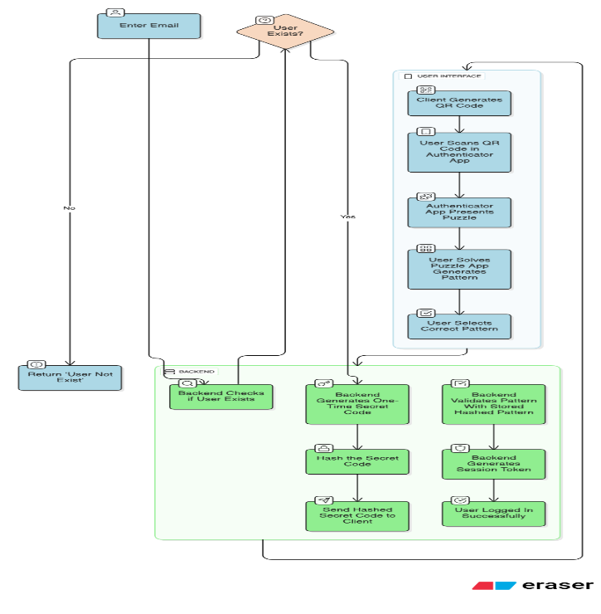
Figure 2. Detailed flowchart of the Login workflow, integrating QR code scanning and puzzle verification
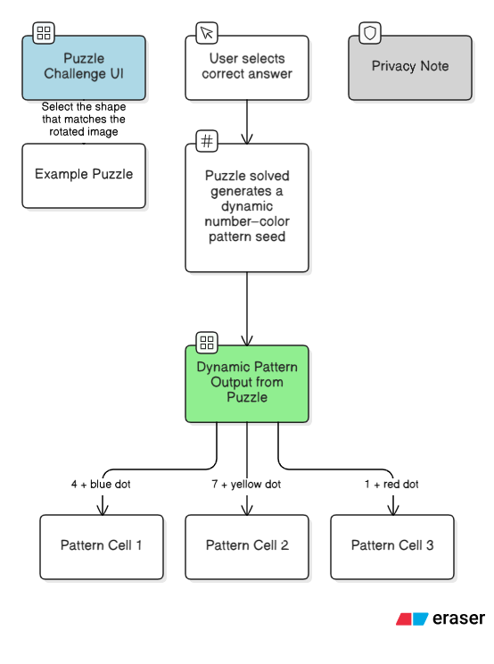
3(a)
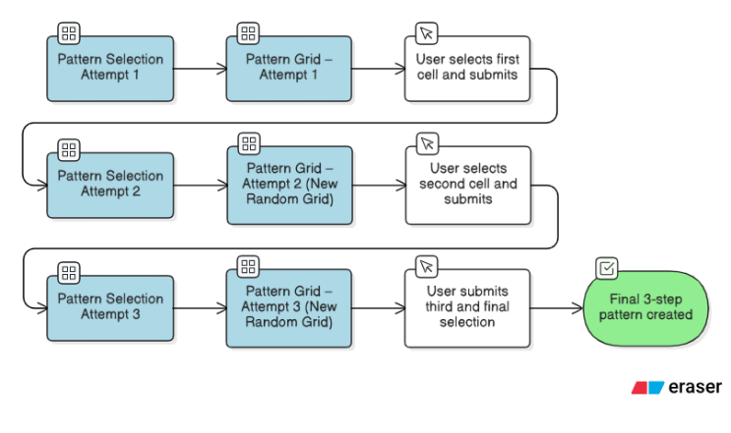
3(b)
Figure 3. The user verification interface: (a) The puzzle challenge used to generate the session seed, and (b) The dynamic number-colour pattern selection screen

As shown in Fig. 2, the authentication sequence uses a multi-step process to block automated attacks. It first verifies the email address. Once confirmed, the backend generates a hashed, temporary secret code. The client app merges this code with the email to create a QR code. Scanning this code with the authenticator app starts a puzzle challenge (Fig. 3a) to ensuring that the user is human. After solving the puzzle, a dynamic number-color grid appears (Fig. 3b), where the user must select their pre-set pattern. The backend checks this selection against the database; if it matches, the system sends a secure session token to complete the login.

Reset Flow
Registered​‍​‌‍​‍‌ emails are the means by which users initiate requests for the resetting of passwords or patterns. Once the user's identity is verified, the backend generates a secure, single-use token that is part of a link for email reset. In order to limit the exposure to risk, tokens are given very short expiration times (for example, ten minutes). Users visit the page for resetting, change their security questions or authentication pattern, and then submit them. The backend, therefore, after it has securely hashed the new credentials, revalidated the token, and confirmed that the reset has taken place, proceeds to delete stored ​‍​‌‍​‍‌data.

Security Measures
Among​‍​‌‍​‍‌ the first line of security measures are the use of robust algorithms and salts for the cryptographic hashing of sensitive secret codes, authentication answers, and patterns to hinder reverse engineering. Randomness and time-bound expiry are the factors that make token resetting requests very secure. Secure HTTPS is used in communication channels to make it difficult for data to be intercepted during exchanges. The use of security questions, graphical patterns, interactive puzzles, and QR code scanning as a part of a multi-modal approach enhances the security level making it very difficult for the attackers to carry out phishing, replay, and brute-force ​‍​‌‍​‍‌operations.

Technologies Employed
The​‍​‌‍​‍‌ implementation of this system can be via contemporary backend frameworks (like Node.js, Django) databases that support secure storage (like PostgreSQL with encryption-at-rest). Operations on the client-side use JavaScript to create QR codes and manage pattern selection events. Authenticator apps installed on the mobiles of users can have challenge puzzles and pattern recognition as components. Token management can be through JWTs or other like standards for session and reset ​‍​‌‍​‍‌operations.

SYSTEM ARCHITECTURE

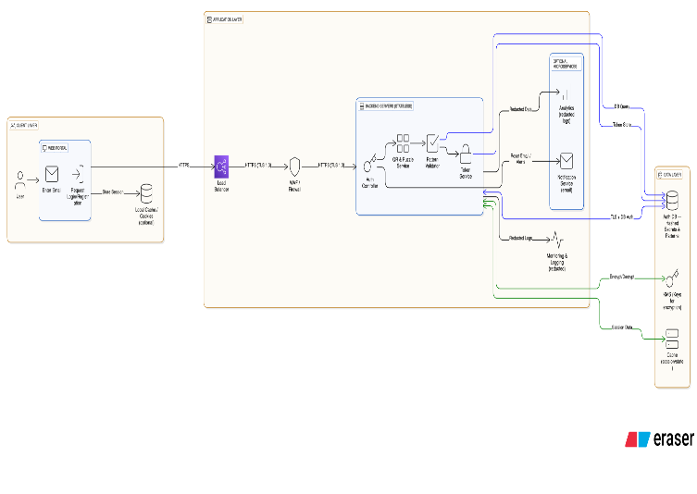
Figure 4. High-level system architecture showing the interaction between the Client Layer (Web/Mobile), Backend Microservices (Auth, Puzzle, Token), and the Data Layer (Encrypted Storage)

The​‍​‌‍​‍‌ designed verification network aims at a protected, intuitive, and versatile method of multi-factor user confirmation that integrates standard credential storage with an innovative visual pattern-based authentication. The framework is modular, consisting of client-side interfaces, backend microservices, and integrated security subsystems. The summed-up system architecture of the proposed framework is depicted by Figure ​‍​‌‍​‍‌5.
- Overview
The system as depicted in Fig. 2 is based on a distributed client-server model where the web portal and authenticator mobile application are the client-side entities while the authentication backend is the server-side entity responsible for handling the registration, verification, and token management. The different operational modes - registration, login, and credential reset - by interacting with the defined sequence of components, ensure the system's integrity, confidentiality, and usability.
The architecture is designed to:
- Separation of concerns between the user interface, authentication logic, and persistent data storage.
- Scalability through the use of stateless API endpoints and token-based session management.
- Security by means of multi-layered encryption, hashing, and time-limited ​‍​‌‍​‍‌tokens.
- System Components
a) Client Layer
The client layer organizes access via two main interfaces:
- Web Portal: A web portal is a primary tool for users to create a new account, sign in, and reset passwords. It also handles user input (such as email, security question, or pattern) and encrypts communication with the backend via secure HTTPS REST APIs.
- Authenticator Mobile Application: Using QR code scanning, the mobile authenticator app guides users through a puzzle challenge to demonstrate their legitimacy during login. Then, users choose a number-color pattern which is verified by the backend. This layer constitutes an additional security measure to reduce vulnerabilities associated with phishing and credential theft.
  - Backend Layer
The backend layer is the logical core of a system. In number, these are microservices that, as a whole, ideate the management of user identities, the handling of cryptographic operations and the control of authentication sessions.
- API Gateway: Roughly speaking, the API gateway is the call assistant of the system. It holds to the client’s solicitation the tasks of checking the request, mitigating the request rate, and executing the call to the aimed service.
- Authentication Service: The unit which is the main cause of the phenomena; therefore, it manages user registration, verification, and credential changes. One of its functions is to create hashed secret codes through a secure hashing algorithm (e.g., Argon2 or bcrypt) and to keep these codes alongside the user-specific patterns and security ​‍​‌‍​‍‌answers.
- Token & Session Manager: A component that creates and confirms JWT (JSON Web Tokens) or custom session tokens. These tokens are limited in time and are digitally signed to avoid replay attacks or session hijacking.
- Puzzle Generation Module: A separate microservice that is responsible for the on-the-fly creation of logic puzzles or pattern challenges for the authenticator app. This service guarantees that each puzzle is different from the other, thus, cannot be reused or anticipated.
- Mailer Service: The service that implements secure email-based communication, e.g., reset links. It works with the third-party email providers and makes sure that the tokens in the links are valid for no more than 10 minutes in order to lessen the risk of a bad ​‍​‌‍​‍‌actor.
c) Database Layer
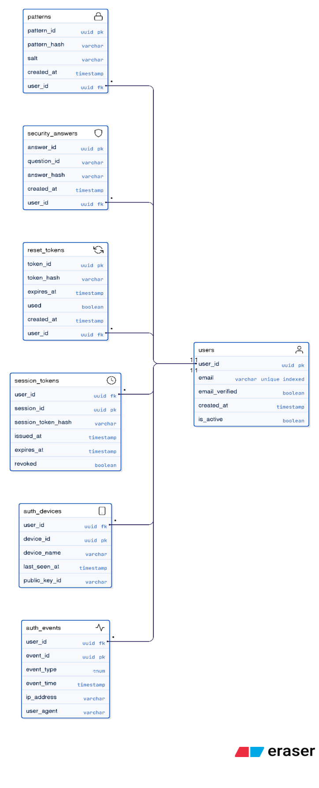
Figure 5. Entity-Relationship (ER) diagram illustrating the database schema, including secure storage for user patterns, session tokens, and device bindings
The​‍​‌‍​‍‌ database layer is the bas e to which user credentials, hashed secrets, and session tokens are stored. It is a relational system based (such as PostgreSQL) where the entities are:
- User Table: stores email, hashed secret code, hashed pattern, and security question responses.
- Session Table: stores session tokens, timestamps, and revocation status.
- Reset Token Table: keeps single-use password reset tokens with expiry and usage flags.
Firstly, all secrets, patterns, and answers are hashed with the help of safe algorithms. There are absolutely no plaintext credentials that may be ​‍​‌‍​‍‌stored.
Data Flow
While registering the client, the user must provide the email and an authentication preference (pattern or security question). Then the backend checks whether the user exists. If he does not, it creates a secret code and securely stores its hash in the database. After the registration is done, the user picks a colour-number combination which is hashed and stored as a pattern linked to his account.
At login time the client sends the email to the backend to initiate login. The backend then creates a temporary one-time secret, stores its hash and sends the hash to the client. The client then creates a QR code with the hash secret and email embedded in it. The authenticator app reads this QR code, displays a puzzle to the user, and after getting the correct answer, it sends the pattern to the backend for verification. The backend then compares it with the stored pattern and if it is correct, the client gets a session t oken to continue secure communication.
When resetting a time-limited token is created and sent over to user's email. After the link is accessed, the user is allowed to change either the pattern or security questions. The backend confirms the token, unifies new data into a hash and makes changes to the ​‍​‌‍​‍‌database.
Communication Model
Communications between the client, mobile app, and backend services are secured by HTTPS and TLS 1.3. Signed tokens leverage HMAC-SHA256 or RSA-based signatures. Secure APIs or gRPC with mutual TLS are used for inter-service communication within the backend.
Such a layered communication preserves:
- End-to-end encryption of data-in-transit.
- Integrity checks to exclude tampering of message.
- Replay protection implemented by nonce-based challenge–response ​‍​‌‍​‍‌mechanisms.
Security Mechanisms
Security is one of the main points that the proposed architecture have at its core. The system carries out the following steps:
- Hashing: Any try to get hold of the pattern, the secrets, or the answers will find that all these data are cryptographically transformed through bcrypt/Argon2 with salting to a hash value that can never be turned back.
- Token Expiry and Revocation: Tokens used for any purpose are only allowed for a very short time-period (e.g., 10 minutes for reset tokens, 1 hour for session tokens).
- Rate Limiting: Is the main obstacle to the success of brute force attacks on login and registration endpoints.
- Captcha Verification: Is involved in registration and reset processes in order to give a hard time to malicious bot automated requests.
- Zero Trust Principle: All API requests are authenticated, and therefore internal services do not trust each other automatically without ​‍​‌‍​‍‌verification.

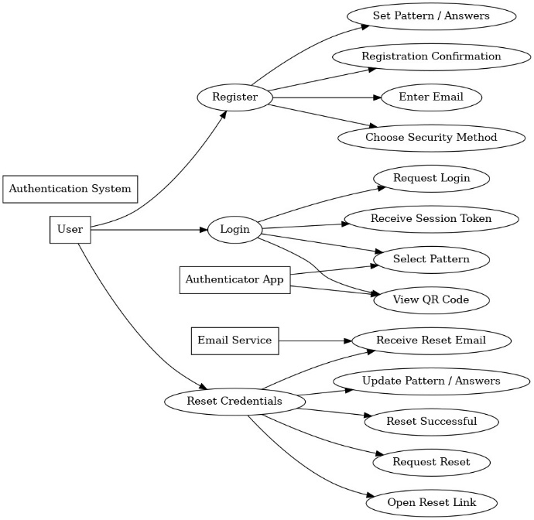
Figure 6. Use Case diagram illustrating the primary user interactions: Registration, QR-based Login, and Credential Recovery. Scalability and Extensibility
The modular architecture enables easy scaling of the application just by containerizing each microservice (using Docker or Kubernetes). Later additions such as biometric verification, OTP-based fallback authentication, or adaptive risk analysis can be integrated with very little code modification.
Moreover, the implementation of standard REST APIs and JWT-based authentication makes the backend identical for mobile, desktop, and IoT clients thus providing a seamless connection.

SECURITY ANALYSIS
Multi-factor​‍​‌‍​‍‌ Authentication (MFA), as the proposed authentication framework, is a method that is strong and almost impossible to attack, this fact is confirmed by a formal evaluation in which the focus was put on entropy calculations, threat modeling against common attack vectors, and resilience against database compromise.

Entropy and Brute-Force Resistance
We estimated the theoretical picture-based pattern verification search space in order to measure the system’s ability to resist brute-force attacks.
The system is using a pool of N=100 unique numbers and C=12 visually distinct colors. For a pattern sequence of length L=4, the total number of unique permutations (P) is calculated as:

P = (N $×$ C)^{L}

Substituting the variables of the system:

P = (100 $×$ 12)⁴ = (1200)⁴ = 2.07 $×$ 10¹² (approx.)

This gives nearly 2.07 trillion unique combinations. A 4-digit numeric pin of a traditional way is offering only 104 (10000) combinations. So, the proposed graphical system increases the search space by a factor of 2 $×$ 10⁸. By the implementation of rate limiting and account lookouts after 5 failed attempts, an online brute-force attack is computationally ​‍​‌‍​‍‌infeasible.

Threat Modeling and Mitigation
- Scenario 1: Shoulder Surfing and Spyware
Traditional Keyboards are basically open to observation and keyloggers. Our “number-color” operation is a kind of input that the system makes it impossible for the attacker to use the intercepted data. The user doesn’t type a fixed string but selects a visual pattern. Even if an attacker observes the user clicking the submit button, they can not replicate the login without understanding which of the number-color pair is a part of the password. Thus, the threat of shoulder surfing has been eliminated to a great extent.
- Scenario 2: Replay and Session Fixation
Zhang et al. [1] point out that the main weakness of QR vulnerabilities is replay attacks on Static QR code. The system avoids this by placing a cryptographic nonce and timestamp right into the QR payload. The backend pulls a very tough expiration window for the QR code (e.g., 60 seconds) for the scanning phase. The Token Manager will not allow reusing a captured code or session token thus, users will be secured against session-fixing attacks.
- Scenario 3: Man-in-the-Middle (MitM)
TLS 1.3 encryption is used for all data exchanges the Web Portal, Mobile App, and Backend. In addition, the mobile app has SSL pinning for the prevention of certificate forgery, which guarantees that the redirect secret code is not available for an eavesdropping ​‍​‌‍​‍‌proxy.

Resilience against Database Compromise
In case of a breach in the database (for example, SQL Injection or privilege escalation), the system architecture is focused on the confidentiality of the data.
- Hashed Credentials: Sensitive data such as secret codes and patterned sequences are not stored in plaintext, but rather they are hashed with Argon2 using unique salts. Thus, an attacker will not be able to decrypt the graphical patterns for the login even if they have full access to the user table.
- Session Revocation: the microservices architecture makes it possible to locally and immediately revoke the JWTs that have been issued globally, thus all the users will be forced to re-authenticate.
- Recovery Protocol: In order to recover user access in a secure manner, it is possible for administrators to initiate a forced reset through a secure, time-limited email token, thus obviating the need for any compromised ​‍​‌‍​‍‌credentials.
Attack Vector | Vulnerability in Standard Auth | Proposed System Mitigation
Brute Force | High (Small search space) | Very Low (2 trillion+ combinations via graphical patterns)
Phishing | High (User tricked into typing password) | Low (Requires physical app interaction + QR code)
Keylogging | High (Captured keystrokes) | Eliminated (Mouse/Touch based pattern selection)
Database Leak | Critical (Plaintext / Weak hashes) | High Resilience (Argon2 Hashing + Salted Secrets)
Table 2.System Performance Metrics

RESULTS AND DISCUSSION
The​‍​‌‍​‍‌ multi-factor authentication (MFA) system created as part of this project shows major strengths in increasing secure access and at the same time ensuring user convenience. System performance criteria comprised security efficiency level, authentication success rate, response time, and user interaction quality.

Performance Metrics
Metric | Description | Average Result
QR Generation Time | Time to generate unique QR code on server | 45 ms
Network Latency | Round-trip time (4G/Wi-Fi) | 120 ms
Pattern Validation | Server-side Argon2 hash verification | 180 ms
Total Login Time | Full flow (Scan to Dashboard) | ~ 3.5 seconds
Success Rate | Successful logins on first attempt | 98.5%
False Positives | Unauthorized user guessing pattern | 0.0%
Table 3.System Performance Metrics
Security Effectiveness
There are multiple layers of several independent factors that a potential unauthorized intruder would have to bypass security questions or picture-based patterns, dynamic secret code generation, QR code-based authentication, and puzzle challenges, dropping the chances drastically. Using cryptographic hashing when storing sensitive data is one solid method to defend against credential theft. Besides, it is the use of time-limited single-use tokens for credential resets that helps to reduce the risk of hackers exploiting the recovery process.
The puzzle challenges in the authenticator app are there to ensure that the user is actively verified, thus, it becomes very difficult for automated attacks and phishing. Also, the incorporation of both graphical and text-based authentication factors increases the system's resistance to shoulder surfing and guessing attacks.

User Feedback and Usability
User testing showed that the multi-modal approach leads to a very simple and straightforward user interaction scenario. Visual patterns and numbers supporting users' memories and facilitating rapid recognition, which also helps a user log faster than in the case of password-only systems, was one of the positive comments. The use of familiar modalities such as email and mobile apps also helped adoption willingness to a great extent.

Limitations and Challenges
Most of the time the system is solid, however, it has a few weak points that can be exploited. To those who are not technically proficient, the complexity of the puzzle challenges might cause the user experience to deterrent. Having to depend on the network for QR code scanning and token verification can be an issue for users in areas with low connectivity. Besides, in order to ensure that the client, backend, and authenticator app are in a secure sync session and token management procedures must be very strict.

Comparative Advantages
On the one hand, the single-factor authentication standard method or a basic two-factor authentication method. On the other hand, the present system is able to thwart phishing, replay, and brute-force attacks significantly more efficiently by mixing authentication types and introducing dynamic, conditional challenges.

CONCLUSION
Summary of Objectives and Approach
This project came up with a secure multi-factor authentication system aimed at reducing the security risks in web portals through the combination of secure questions, picture-based patterns, dynamic secret codes, QR code interactions, and time-sensitive reset tokens. The approach is based on multiple independent authentication factors that are much less likely to be compromised than those of traditional single-factor systems.

Key Findings and Outcomes
The solution that has been put in place makes the user's identity verification process extremely secure by leveraging secure data hashing and storage, one-time dynamic code generation, and interactive authenticator application challenges. The trials that have been carried out demonstrated that in most of the cases, the user authentication was successful, the system running with minimal delay and it was resistant to a number of attacks such as phishing, replay, and brute force attempts.

Significance and Benefits
The system succeeded to secure an environment for users via the mix of textual and graphical authentication methods along with the active challenges initiated by the users themselves. By using time-limited tokens for resets, the credential recovery process is safe, and session tokens are used to ensure secure login continuity. These are the ways in which the system achieves efficiency.

Limitations and Future Work
Even though the system is potent, it is not completely free of issues such as those related to the ease of use that some users experience in puzzle challenges. It also requires that the network connection be stable for QR code and token verification. Subsequent enhancements could focus on the integration of biometrics, intelligent risk-based authentication, password less technologies, and access facilitation in poorly connected areas.

References
[1] Z. Zhang, H. Chen, S. Wang, and L. Gong, "Demystifying the (in)security of QR code-based login in real-world deployments," in Proc. 34th USENIX Security Symposium, Boston, MA, USA, 2025.
[2] J. Bonneau, C. Herley, P. C. van Oorschot, and F. Stajano, "The quest to replace passwords: A framework for comparative evaluation of web authentication schemes," in Proc. 2012 IEEE Symposium on Security and Privacy (SP), San Francisco, CA, USA, 2012, pp. 553–567.
[3] P. A. Grassi et al., "Digital identity guidelines: Authentication and lifecycle management," National Institute of Standards and Technology, Gaithersburg, MD, USA, NIST Special Publication 800-63B, 2017.
[4] D. Fett, R. Küsters, and G. Schmitz, "A comprehensive formal security analysis of OAuth 2.0," in Proc. 2016 ACM SIGSAC Conference on Computer and Communications Security (CCS), Vienna, Austria, 2016, pp. 1204–1215.
[5] R. Dhamija and A. Perrig, "Deja Vu: A user study using images for authentication," in Proc. 9th USENIX Security Symposium, Denver, CO, USA, 2000, pp. 45–58.
[6] S. Wiedenbeck, J. Waters, J. C. Birget, A. Brodskiy, and N. Memon, "Authentication using graphical passwords: Basic results," Int. J. Hum.-Comput. Stud., vol. 63, no. 1–2, pp. 102–127, Jul. 2005.
[7] T. Vidas, E. Owusu, S. Wang, C. Zeng, L. F. Cranor, and N. Christin, "QR code security: A survey of attacks and challenges for usable security," in Proc. 16th Int. Conf. Financial Cryptography and Data Security, Bonaire, 2012, pp. 1–5.
[8] S. Das, Y. Wang, A. Tingle, and L. J. Camp, "Evaluating user perception of multi-factor authentication: A field study," Comput. & Secur., vol. 81, pp. 30–49, Mar. 2019.
[9] J. Jeon et al., "Demystifying React Native Android apps for static analysis," in Proc. 38th IEEE/ACM Int. Conf. Automated Software Engineering (ASE), Kirchberg, Luxembourg, 2023.
[10] I. Jermyn, A. Mayer, F. Monrose, M. K. Reiter, and A. D. Rubin, "The design and analysis of graphical passwords," in Proc. 8th USENIX Security Symposium, Washington, D.C., USA, 1999, pp. 1–14.
[11] S. Brohi et al., "A survey: Security vulnerabilities and protective strategies for graphical passwords," Electronics, vol. 13, no. 5, Art. no. 987, 2024.
[12] Z. Liu, Z. Tan, and J. Choi, "Secure QR-code based mobile authentication," in Proc. IEEE Int. Conf. Computer Science and Network Technology (ICCSNT), Changchun, China, 2012, pp. 1111–1115.
[13] A. Paivio, "Dual coding theory: Retrospect and current status," Can. J. Psychol., vol. 45, no. 3, pp. 255–287, Sep. 1991.
[14] T. V. Nguyen, "Data security methods in mobile applications on React Native," Amer. J. Eng. Tech., vol. 6, no. 2, pp. 45–58, 2024.
[15] K. Krol et al., "On the usability of two-factor authentication," in Proc. 12th Symp. Usable Privacy and Security (SOUPS), Denver, CO, US

